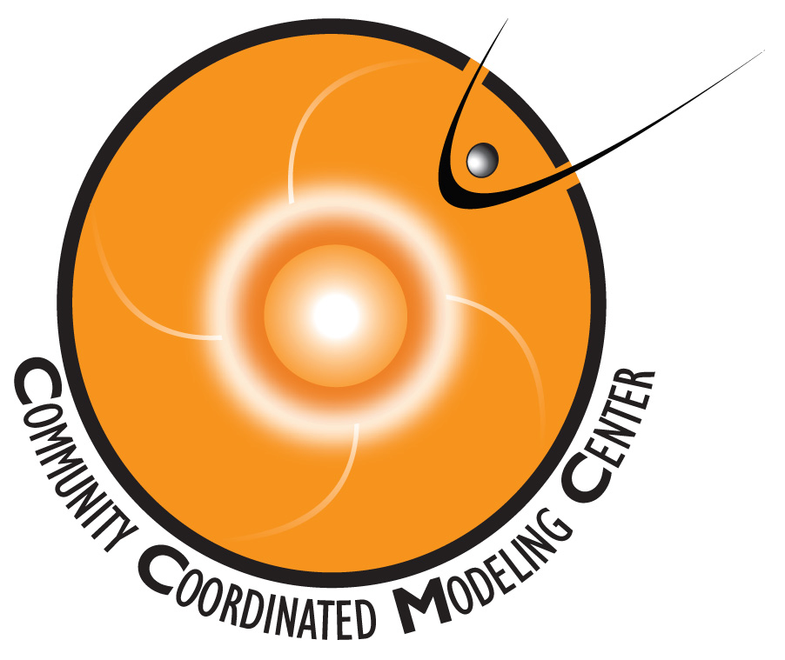
CCMC Student Research Contest
Application Deadlines:
- Space Weather category: February 18, 2014
- Solar, Magnetosphere, and Ionosphere categories: May 1, 2014

NAME (Last, First, Middle Initial)
____________________________________________________________________________
AFFILIATION ____________________________________________________________________________
ADDRESS & PHONE NUMBER ____________________________________________________________________________
CITY: ________________________________________ STATE: ________ ZIP: ___________
EMAIL:______________________________________________________________________
WHAT DEGREE ARE YOU WORKING TOWARDS: ____________________________________________________________________________
SUPERVISOR NAME & PHONE NUMBER
____________________________________________________________________________
FIELD(S) OF INTEREST
Solar Heliosphere Magnetosphere Ionosphere Thermosphere Space Weather Other ( please specify ) _______________________________________________________
TITLE OF RESEARCH PROJECT ________________________________________________
CCMC TOOLS USED ____________________________________________________________________________
If your project is selected, which conference do you prefer?
Please e-mail your completed application along with your research report (not to exceed 10 pages) to Rebekah.e.frolov@nasa.gov
Space Weather Week (Feb. 18 deadline only!) SHINE GEM CEDAR

