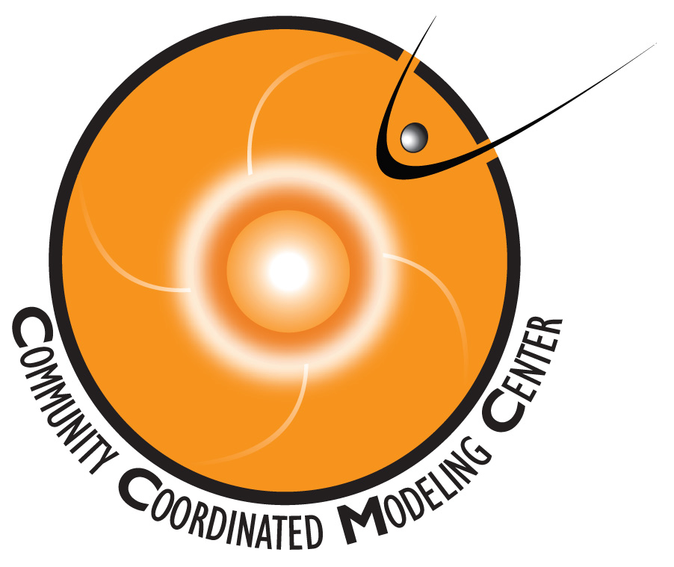
CCMC Student Research Contest
Application Deadline: May 7, 2013

NAME (Last, First, Middle Initial)
____________________________________________________________________________
AFFILIATION ____________________________________________________________________________
ADDRESS & PHONE NUMBER ____________________________________________________________________________
CITY: ________________________________________ STATE: ________ ZIP: ___________
EMAIL:______________________________________________________________________
WHAT DEGREE ARE YOU WORKING TOWARDS: ____________________________________________________________________________
SUPERVISOR NAME & PHONE NUMBER
____________________________________________________________________________
FIELD(S) OF INTEREST
Solar Heliosphere Magnetosphere Ionosphere Thermosphere Space Weather Other ( please specify ) _______________________________________________________
TITLE OF RESEARCH PROJECT ________________________________________________
CCMC TOOLS USED ____________________________________________________________________________
If your project is selected, which conference do you prefer? SHINE GEM CEDAR
Please e-mail your completed application along with your research report (not to exceed 10 pages) to Rebekah.e.frolov@nasa.gov by the deadline: May 7, 2013.

